Tutorial Maven – Construindo um projeto java
- No Eclipse acessar New/Project Maven
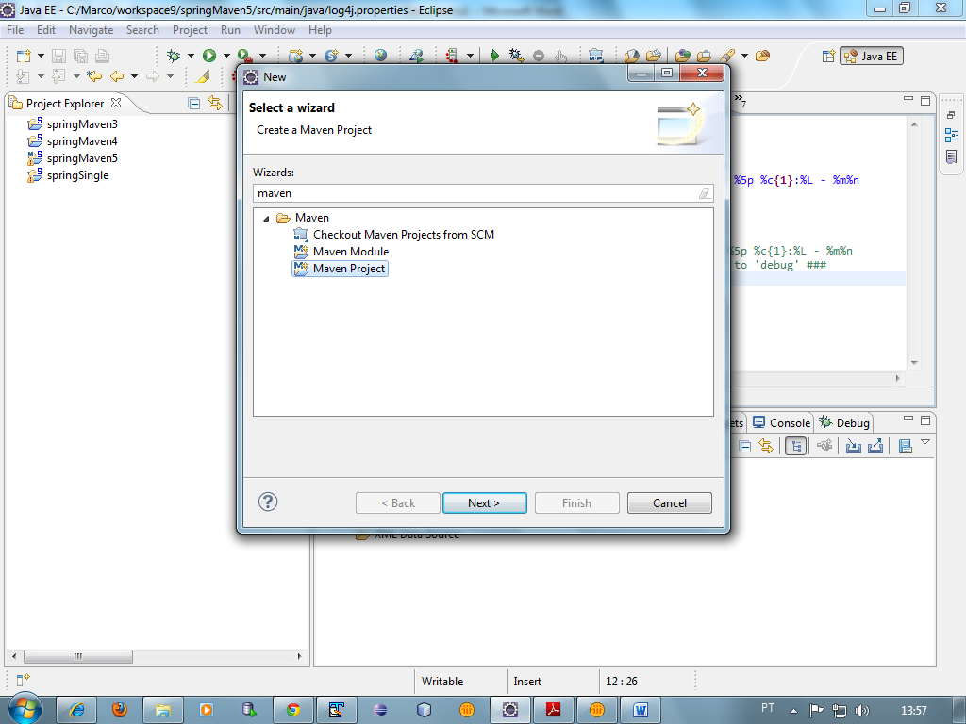
2.Utilizar o archetype.quickstart
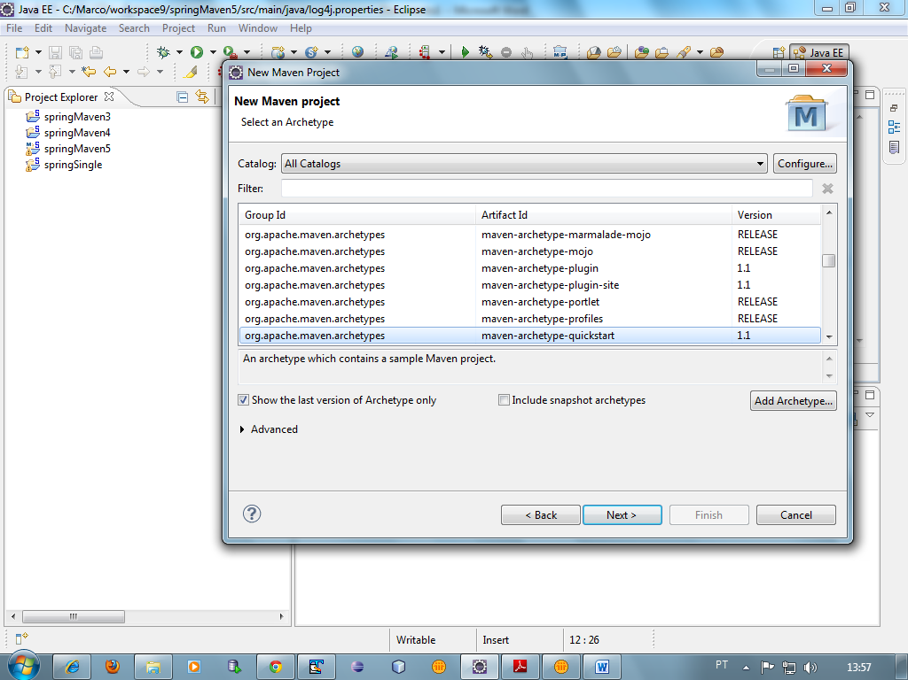

- Na pasta src/main/java, criar a pasta META-INF e a package do projeto
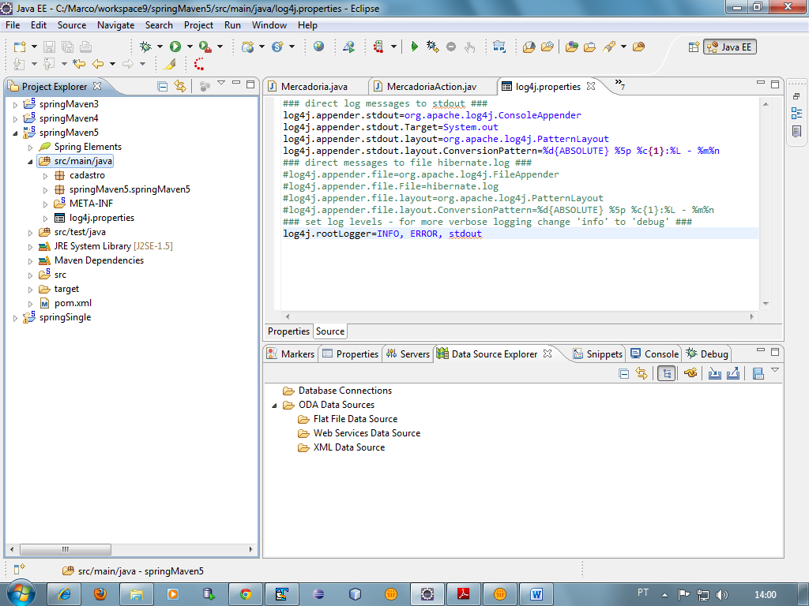
- Criar a interface de implementação.

package cadastro;

public interface Cadastro {

public void show();
}

- Criar o programa java abaixo.

package cadastro;

import org.springframework.stereotype.Component;

@Component
public class Mercadoria implements Cadastro {

public void show() {

System.out.println("Mercadoria.show()");

}

}

- Criar o programa starter.

package cadastro;

import org.springframework.context.ApplicationContext;
import org.springframework.context.support.ClassPathXmlApplicationContext;

public class MercadoriaAction {

/**
* @param args
*/
public static void main(String[] args) {

ApplicationContext context = new ClassPathXmlApplicationContext("classpath:**/applicationContext.xml");

Cadastro mercadoria = (Cadastro) context.getBean("mercadoria");

mercadoria.show();

}

}

- Criar o pom.xml

<project xmlns="http://maven.apache.org/POM/4.0.0" xmlns:xsi="http://www.w3.org/2001/XMLSchema-instance"
xsi:schemaLocation="http://maven.apache.org/POM/4.0.0 http://maven.apache.org/xsd/maven-4.0.0.xsd">
<modelVersion>4.0.0</modelVersion>

<groupId>springMaven5</groupId>
<artifactId>springMaven5</artifactId>
<version>0.0.1-SNAPSHOT</version>
<packaging>jar</packaging>

<name>springMaven5</name>
<url>http://maven.apache.org</url>

<properties>
<project.build.sourceEncoding>UTF-8</project.build.sourceEncoding>
<!-- Versão do spring -->
<spring.version>3.1.0.RELEASE</spring.version>
<!-- Versão do spring Security -->
<spring.security.version>3.1.0.RELEASE</spring.security.version>
<!-- Versão do jstl -->
<jstl.version>1.2</jstl.version>
<!-- Mapeamento de diretório -->
<endorsed.dir>${project.build.directory}/endorsed</endorsed.dir>
<!-- Encoding do projeto -->
<project.build.sourceEncoding>UTF-8</project.build.sourceEncoding>
</properties>

<dependencies>
<dependency>
<groupId>junit</groupId>
<artifactId>junit</artifactId>
<version>3.8.1</version>
<scope>test</scope>
</dependency>
<dependency>
<groupId>org.springframework</groupId>
<artifactId>spring-context</artifactId>
<version>${spring.version}</version>
</dependency>
<dependency>
<groupId>log4j</groupId>
<artifactId>log4j</artifactId>
<version>1.2.15</version>
<exclusions>
<exclusion>
<groupId>javax.mail</groupId>
<artifactId>mail</artifactId>
</exclusion>
<exclusion>
<groupId>javax.jms</groupId>
<artifactId>jms</artifactId>
</exclusion>
<exclusion>
<groupId>com.sun.jdmk</groupId>
<artifactId>jmxtools</artifactId>
</exclusion>
<exclusion>
<groupId>com.sun.jmx</groupId>
<artifactId>jmxri</artifactId>
</exclusion>
</exclusions>
<type>jar</type>
</dependency>
<dependency>
<groupId>org.springframework</groupId>
<artifactId>spring-test</artifactId>
<version>${spring.version}</version>
<type>jar</type>
</dependency>
</dependencies>

<repositories>
<!-- Maven Central -->
<repository>
<id>org.maven.central</id>
<name>Maven Central Repository</name>
<url>http://repo1.maven.org/maven2</url>
<snapshots>
<enabled>false</enabled>
</snapshots>
</repository>
<!-- For testing against latest Spring snapshots -->
<repository>
<id>org.springframework.maven.snapshot</id>
<name>Spring Maven Snapshot Repository</name>
<url>http://maven.springframework.org/snapshot</url>
<releases>
<enabled>false</enabled>
</releases>
<snapshots>
<enabled>true</enabled>
</snapshots>
</repository>
<!-- For developing against latest Spring milestones -->
<repository>
<id>org.springframework.maven.milestone</id>
<name>Spring Maven Milestone Repository</name>
<url>http://maven.springframework.org/milestone</url>
<snapshots>
<enabled>false</enabled>
</snapshots>
</repository>
</repositories>
</project>

- Criar o log4j.properties

### direct log messages to stdout ###
log4j.appender.stdout=org.apache.log4j.ConsoleAppender
log4j.appender.stdout.Target=System.out
log4j.appender.stdout.layout=org.apache.log4j.PatternLayout
log4j.appender.stdout.layout.ConversionPattern=%d{ABSOLUTE} %5p %c{1}:%L - %m%n
### direct messages to file hibernate.log ###
#log4j.appender.file=org.apache.log4j.FileAppender
#log4j.appender.file.File=hibernate.log
#log4j.appender.file.layout=org.apache.log4j.PatternLayout
#log4j.appender.file.layout.ConversionPattern=%d{ABSOLUTE} %5p %c{1}:%L - %m%n
### set log levels - for more verbose logging change 'info' to 'debug' ###
log4j.rootLogger=INFO, ERROR, stdout

- Resultado Final
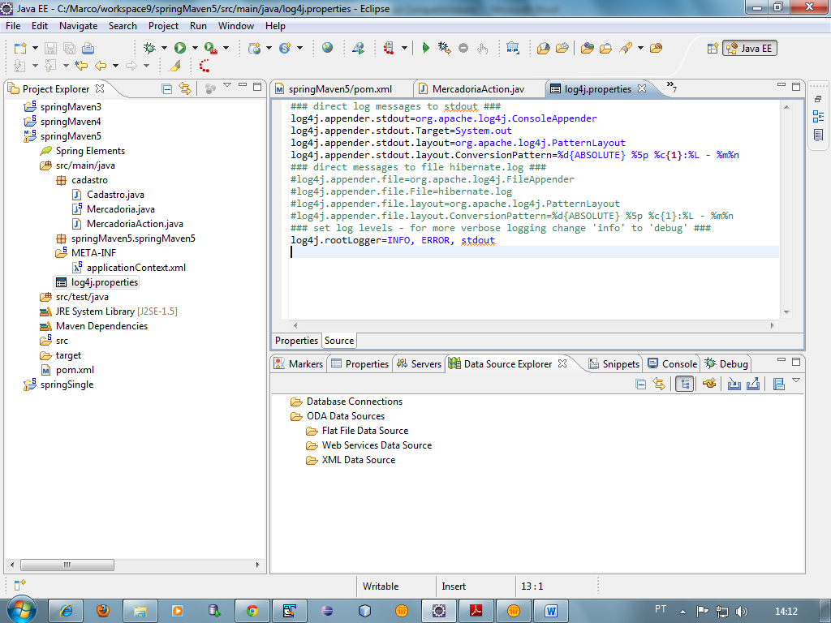

- Criar o applicationContext.xml

<?xml version="1.0" encoding="UTF-8"?>
<beans xmlns="http://www.springframework.org/schema/beans"
xmlns:xsi="http://www.w3.org/2001/XMLSchema-instance"
xmlns:context="http://www.springframework.org/schema/context"
xsi:schemaLocation="http://www.springframework.org/schema/beans http://www.springframework.org/schema/beans/spring-beans-3.1.xsd
http://www.springframework.org/schema/context http://www.springframework.org/schema/context/spring-context-3.1.xsd">

<context:component-scan base-package="cadastro"></context:component-scan>
</beans>

